CIS 310

Homework 1

Rodney Fulk

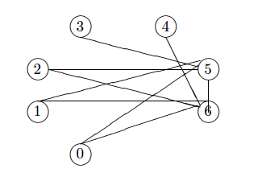

List of Edges:

0 5

0 6

1 5

1 6

2 5

2 6

3 5

4 6

5 6

Adjacency List

5 6

5 6

5 6

5

6

0 1 2 3 6

0 1 2 4 5

Adjacency Matrix (Please note that I labeled the headings to reduce confusion):

|  |  |  |  |  |  |  |  |
| --- | --- | --- | --- | --- | --- | --- | --- |
|  | **0** | **1** | **2** | **3** | **4** | **5** | **6** |
| **0** | 0 | 0 | 0 | 0 | 0 | 1 | 1 |
| **1** | 0 | 0 | 0 | 0 | 0 | 1 | 1 |
| **2** | 0 | 0 | 0 | 0 | 0 | 1 | 1 |
| **3** | 0 | 0 | 0 | 0 | 0 | 1 | 0 |
| **4** | 0 | 0 | 0 | 0 | 0 | 0 | 1 |
| **5** | 1 | 1 | 1 | 1 | 0 | 0 | 1 |
| **6** | 1 | 1 | 1 | 0 | 1 | 1 | 0 |